NB using SLIC

Accuracy 85.38011695906432%

[[114 43]

[ 7 178]]

[STATUS] splitted train and test data...

Train data : (1367, 549)

Test data : (342, 549)

Precision=TP/TP+FP: 94.21487603305785 %

Sensitivity=TP/TP+FN: 72.61146496815287 %

Specificity=TN/TN+FP: 96.21621621621621 %

SVM using SLIC

Accuracy: 95.6140350877193%

[[154 3]

[ 12 173]]

154

Precision=TP/TP+FP: 92.7710843373494 %

Sensitivity=TP/TP+FN: 98.08917197452229 %

Specificity=TN/TN+FP: 93.51351351351352 %

NB using masking

Accuracy 86.8421052631579%

[[117 40]

[ 5 180]]

[STATUS] splitted train and test data...

Train data : (1367, 549)

Test data : (342, 549)

Precision=TP/TP+FP: 95.90163934426229 %

Sensitivity=TP/TP+FN: 74.52229299363057 %

Specificity=TN/TN+FP: 97.29729729729729 %

SVM using masking

Accuracy: 93.85964912280701%

[[149 8]

[ 13 172]]

149

Precision=TP/TP+FP: 91.9753086419753 %

Sensitivity=TP/TP+FN: 94.90445859872611 %

Specificity=TN/TN+FP: 92.97297297297297 %

**Using masking**

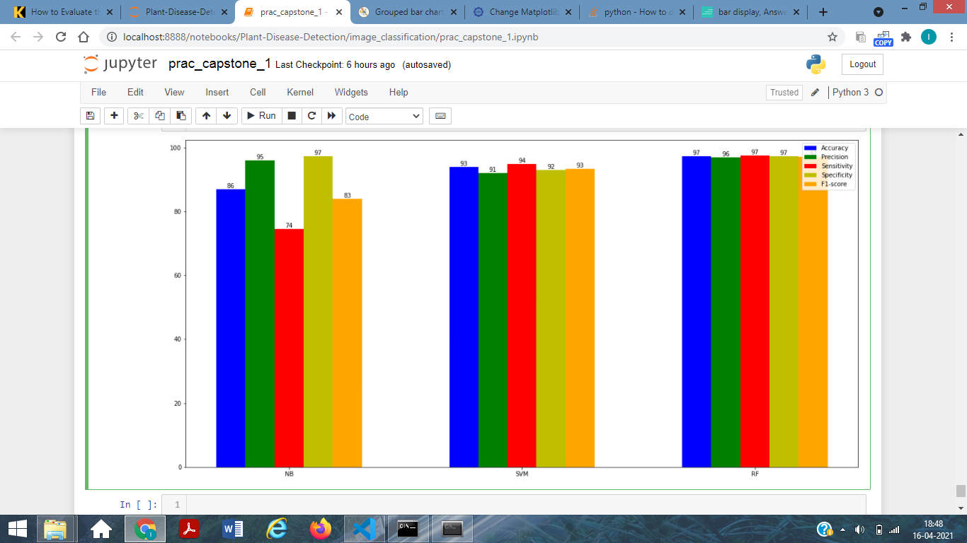

|  |  |  |  |  |  |
| --- | --- | --- | --- | --- | --- |
| Algo used | Accuracy(%) | Precision(%) | Sensitivity(%) | Specificity(%) | F1_score(%) |
| Gaussian Naive Bayes | 86.842105 | 95.901639 | 74.522293 | 97.297297 | 83.870968 |
| Support Vector Machine | 93.859649 | 91.975309 | 94.904459 | 92.972973 | 93.416928 |
| Random Forest | 97.368421 | 96.835443 | 97.452229 | 97.297297 | 97.142857 |

Using SLIC

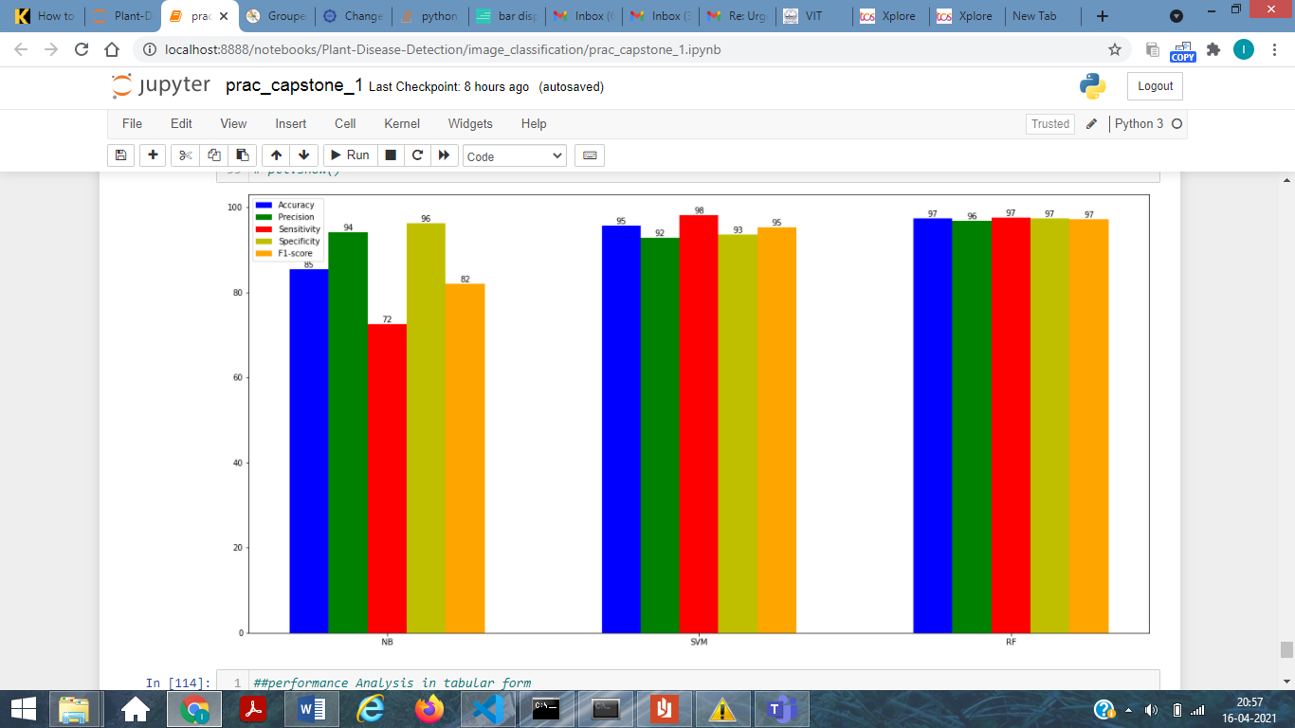

|  |  |  |  |  |  |
| --- | --- | --- | --- | --- | --- |
| Algo used | Accuracy(%) | Precision(%) | Sensitivity(%) | Specificity(%) | F1_score(%) |
| Gaussian Naive Bayes | 85.380117 | 94.214876 | 72.611465 | 96.216216 | 82.014388 |
| Support Vector Machine | 95.614035 | 92.771084 | 98.089172 | 93.513514 | 95.356037 |
| Random Forest | 97.368421 | 96.835443 | 97.452229 | 97.297297 | 97.142857 |